Lab 5

Task 1

1. You are given the following html file.

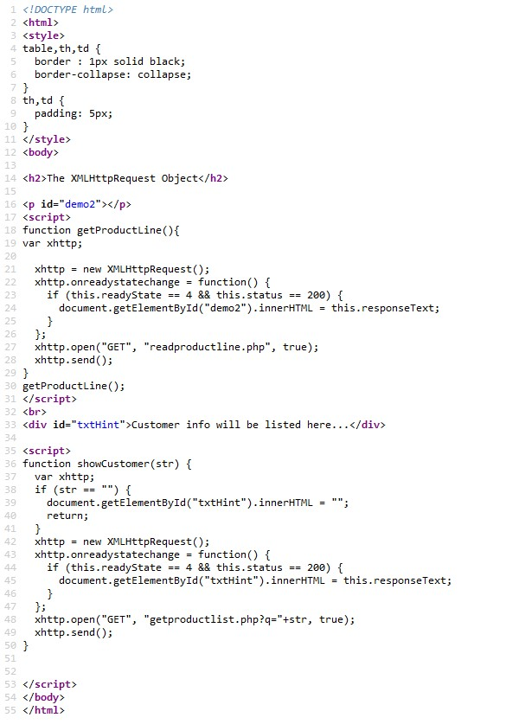

1. And part of php file that returned the data according to the user selection

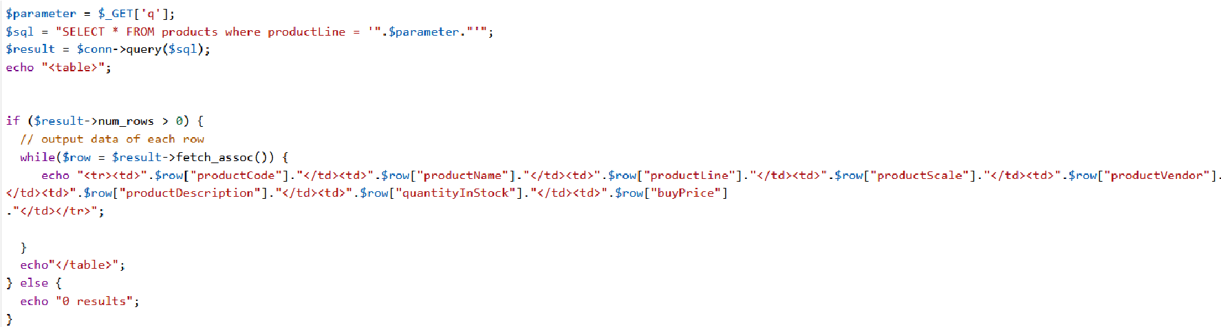

1. Another supporting file is a php that returned the list for customer choice

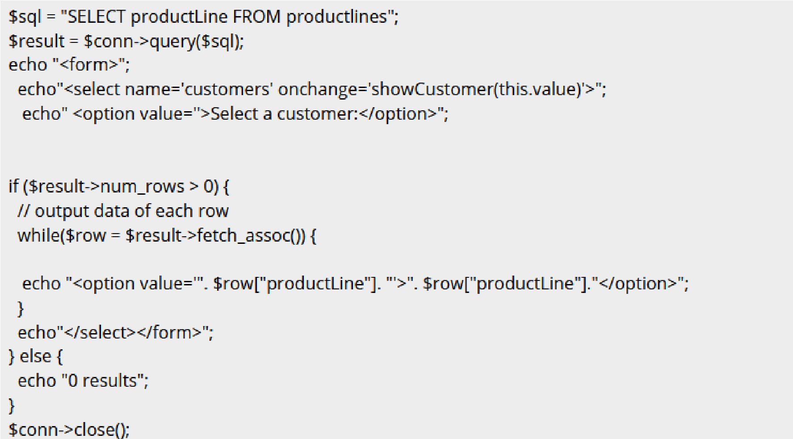

All those three (3) files is hosted at [http://skimtech.my](http://skimtech.my/)

Evaluate the given file, and answer the questions:

1. What is the name of first php file?

* readproductline.php

1. What is the name of second php file?

* getproductlist.php

1. Recognised the item in the select option.

* Classic Cars, Motorcycles, Planes, Ships, Trains, Trucks and Buses,

Vintage Cars.

1. What is returned by the second php file.

* Return select option.

1. Can you examine how both file is called from html file?

* Using XMLHttpRequest object created by JavaScript.

Task 2

You are given the following php file that returned the data as above second php file. But this time it’s returned in a form of JSON.

You can play around the php file by the following URL

https://skimtech.my/getProductByChoice.php?q= <replace with one item you recognised in question (3) above>.

1. How many records are there belonging to motorcycles type?

* 13 records.

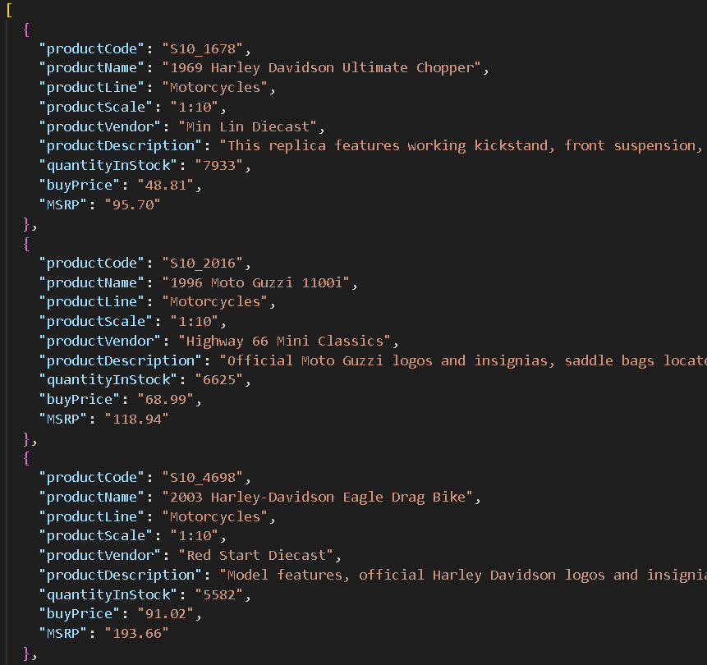

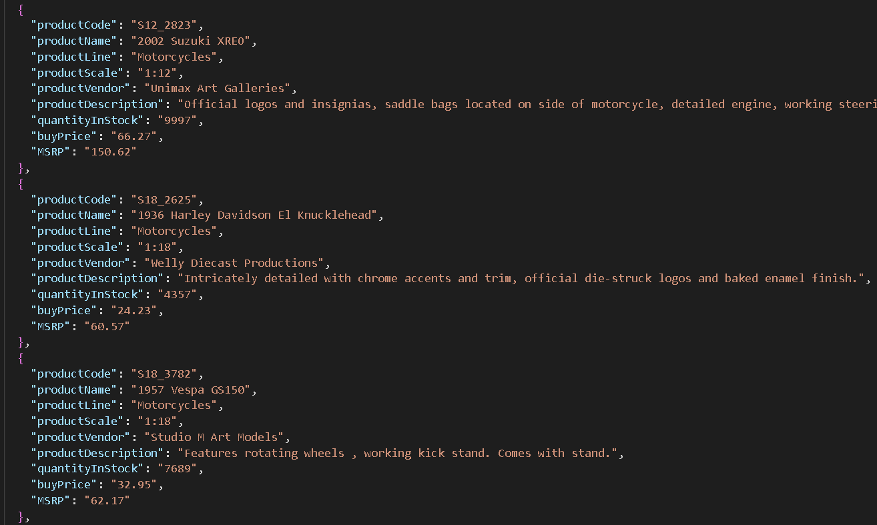

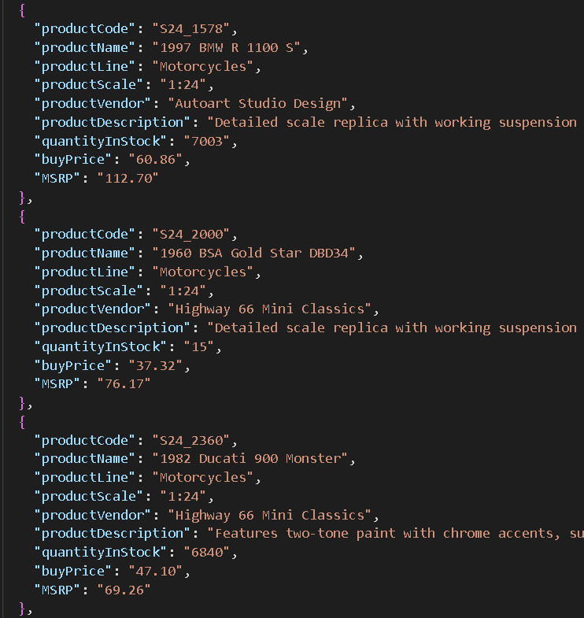

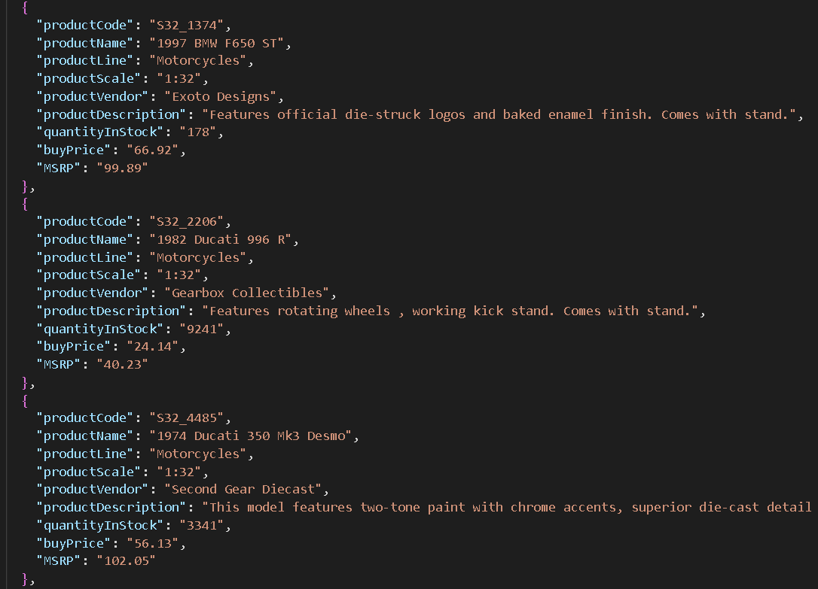

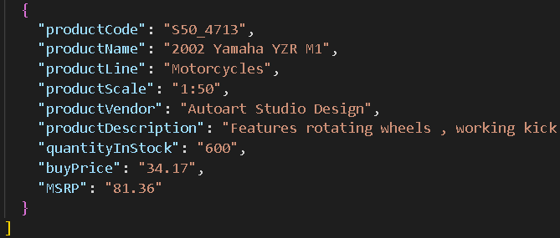

1. What are attributes in each of the record?

* productCode, productName, productLine, productScale, productVendor, productDescription, quantityInStrock, buyPrice, MSRP.

Write you own html file, which have the select option as item in question 3 above and make a XMLHttp called to getProductByChoice and pass the selected options as a parameter.

1. Display all the returned JSON data into a table with the header
2. Display the Data one by one according to click function

Here is part of usefull code of getProductByChoice.php,

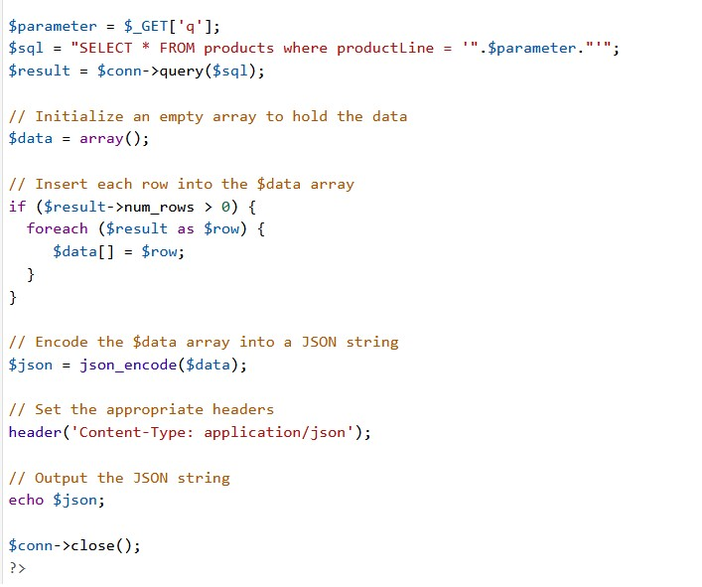

Index.html

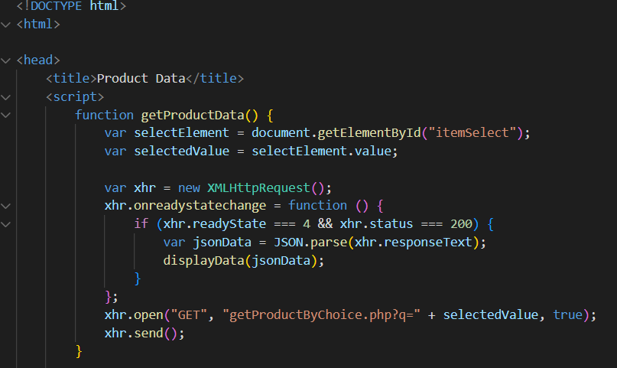

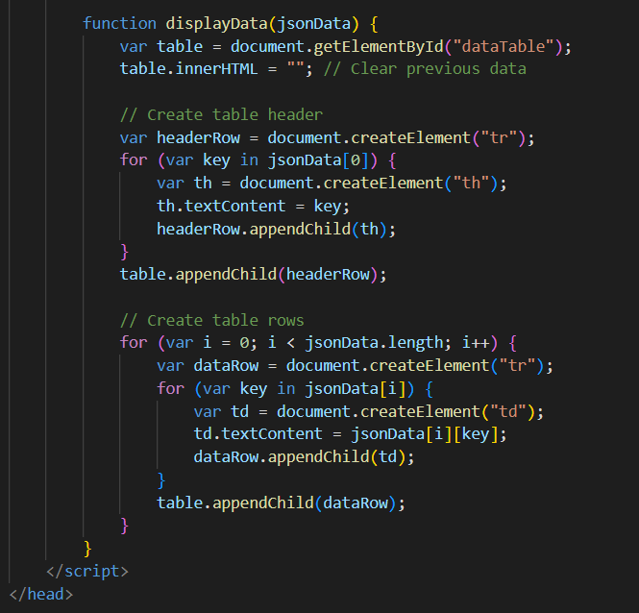

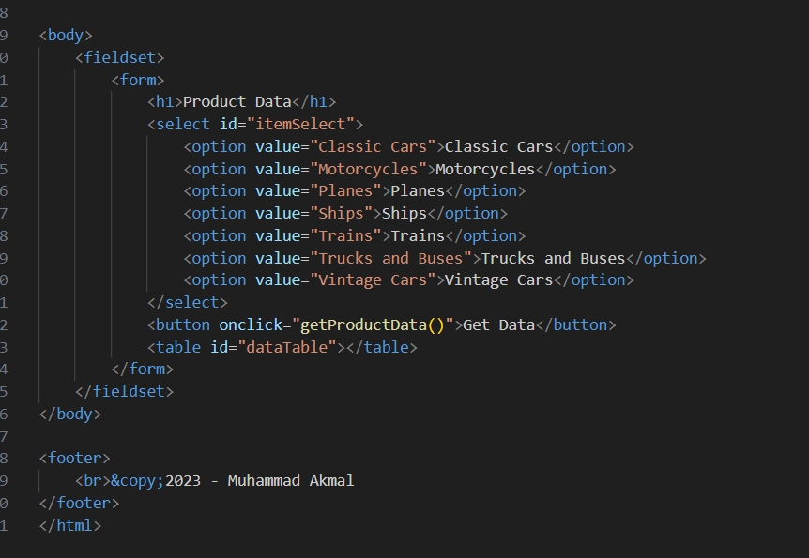

getProductbyChoice.php

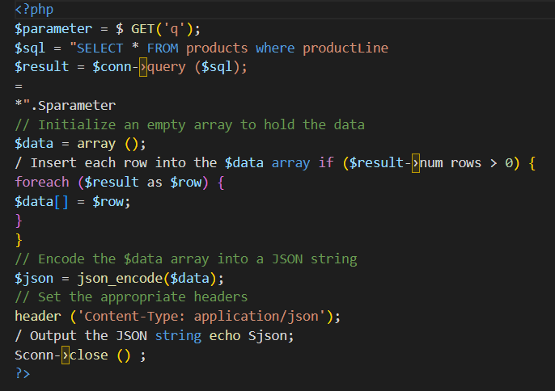

displayData.js

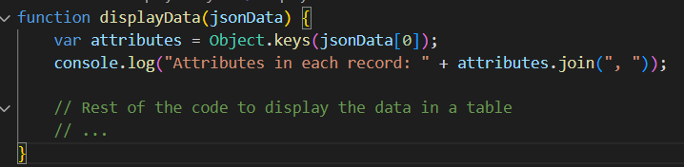

Output:

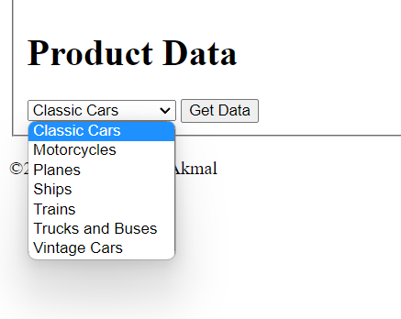

Link GitHub:

https://github.com/akmlmhd/Lab.git